5.36: a) The normal force will be 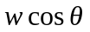 and the component of the gravitational force along the ramp is 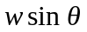. The box begins to slip when 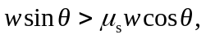 or 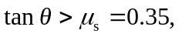 so slipping occurs at 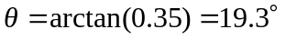, or 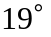 to two figures.
b) When moving, the friction force along the ramp is 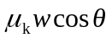, the component of the gravitational force along the ramp is 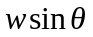, so the acceleration is
(c) 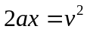, so 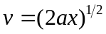, or 